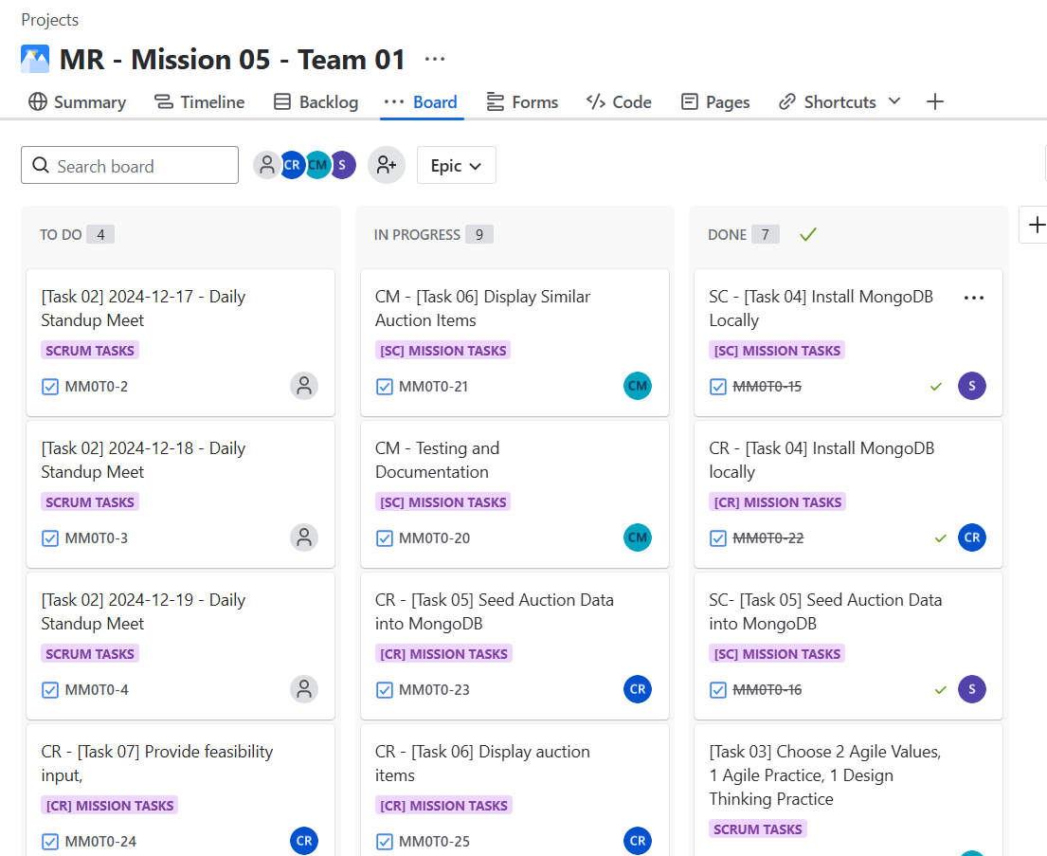

Daily standup

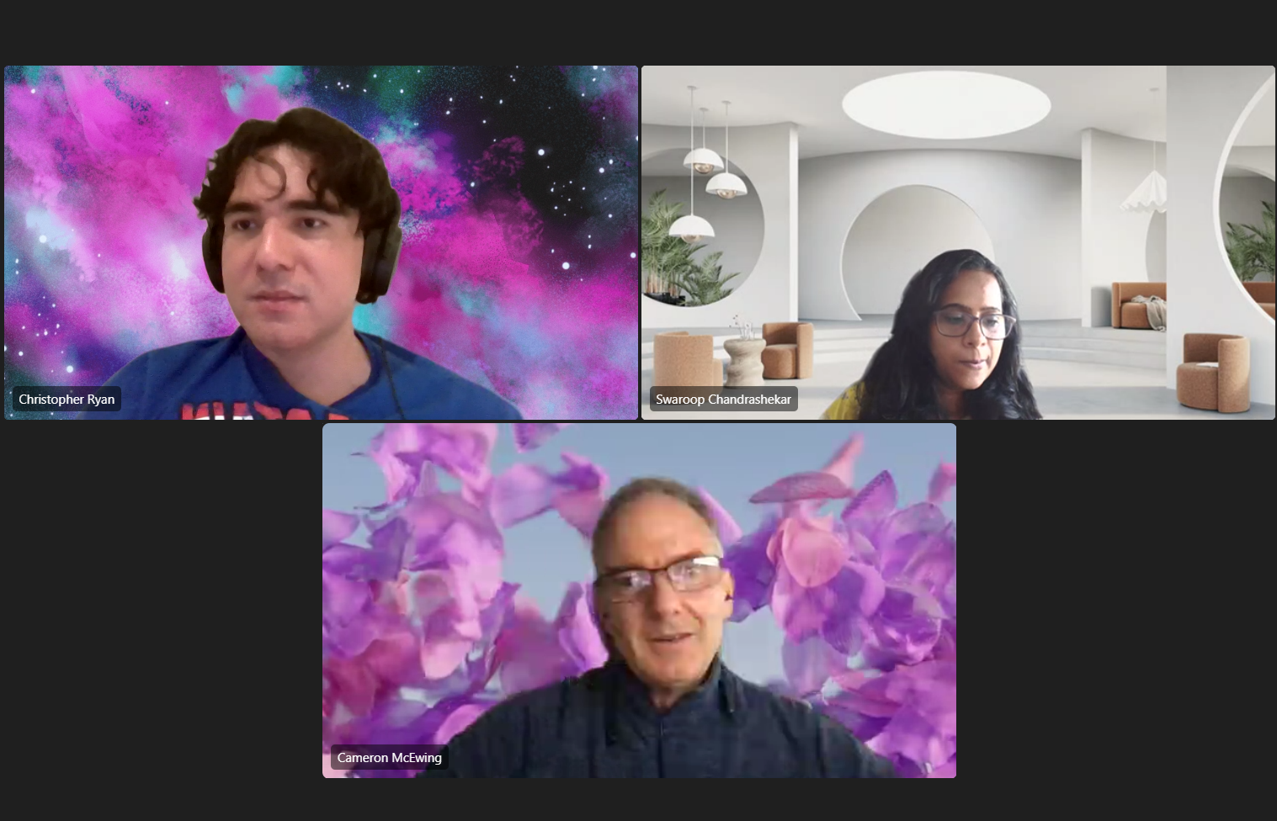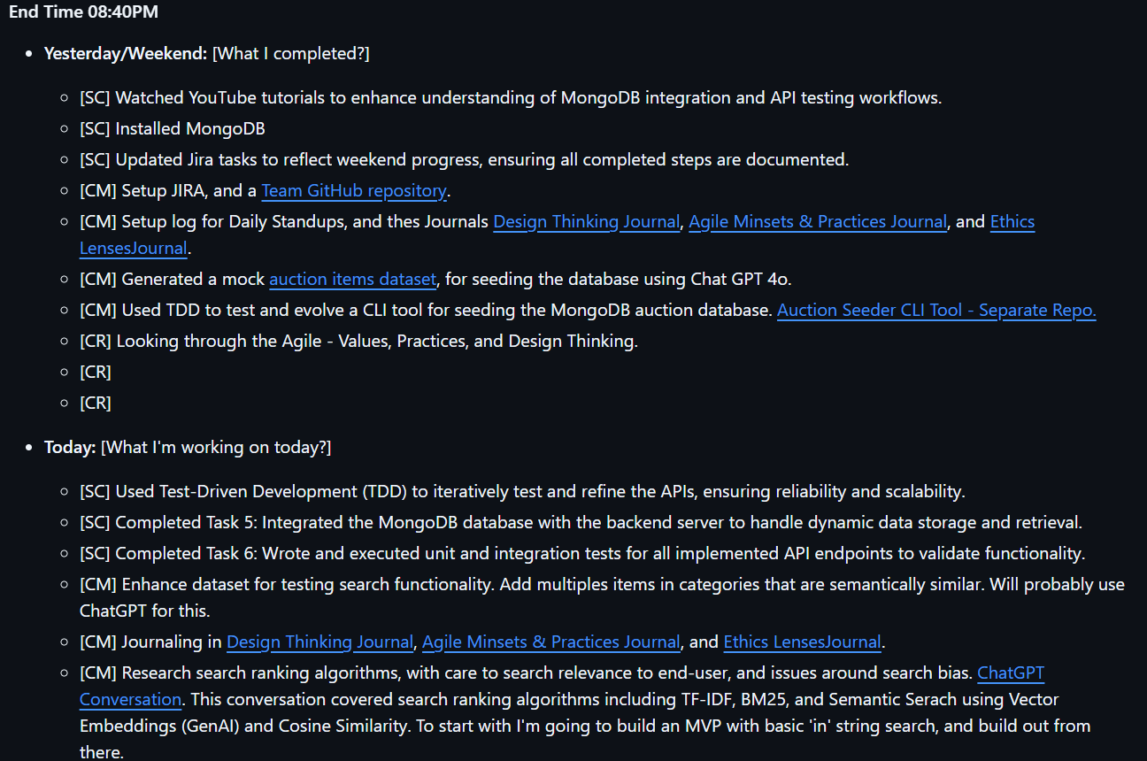

Individuals and interactions over processes and tools

While doing standups were useful, any issues we had were dealt with after the meetings, with all of us getting together to help eachother

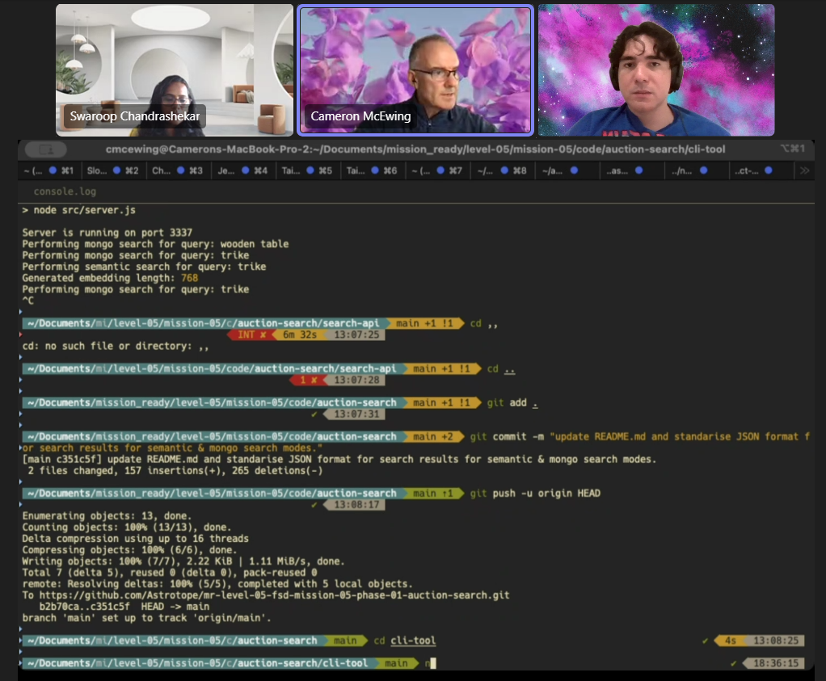

Working software over comprehensive documentation

While readmes are vital, self documenting code which actually works is more important if this practice is to be followed.